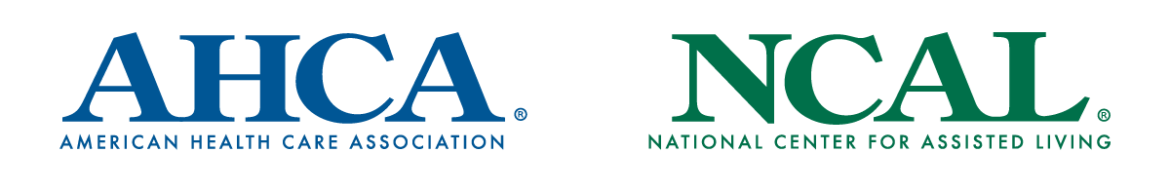

Template Newsletter Article

COVID-19 Vaccine Updates
The past year has been incredibly difficult. The COVID-19 pandemic has upended so many of our lives and separated us from our loved ones. We have suffered a devastating loss of lives on a proportion we could not have imagined.

The rapid development of COVID-19 vaccines is a scientific feat that will be marveled at for years to come. They have offered us hope at a time when we desperately need it. This is incredible news and something worth celebrating in this challenging year.

Due to the disproportionate impact COVID-19 has had on long term care, the Centers for Disease Control and Prevention recommended that long term care residents and staff be included at the highest priority level for the first distributions of this life-saving vaccine.

As soon as we learned we would be prioritized for the vaccine, we began encouraging as many residents and staff as possible to get this vaccine. We knew that the more residents and staff that are vaccinated, the better we can protect our community against potential outbreaks and save lives.

However, we also knew that the speed at which these vaccines are developed and the misinformation surrounding the vaccine made some individuals hesitant. We understood their concerns and deployed several strategies to listen to these worries, educate on the safety and benefits of the vaccine, and celebrate those who agreed to receive the vaccine. This includes [insert strategies the facility undertook to encourage vaccination.]

I am proud to announce that, today, XX% of residents and XX% of our staff have received the vaccine. We plan to continue our work to promote vaccine confidence and have set a bold goal of achieving [insert goal, such as 75% uptake among staff and residents.]

We are also excited to share some information on the effectiveness of the vaccine. Since our first vaccination clinic, we have seen [insert relevant results (e.g. a decrease in cases, no outbreaks, etc. etc.)

You can rest assured that we continue to take all necessary precautions to ensure the safety of our staff and residents, including wearing personal protective equipment and conducting regular testing. We are also working with public health officials to determine how and when we can adjust our policies for visitations and social activities. We will keep you updated.

There is a light at the end of the tunnel. Please do not hesitate to reach out to us with any questions. You may also visit www.cdc.gov/coronavirus/2019-ncov/vaccines to learn more about the vaccine.

###

